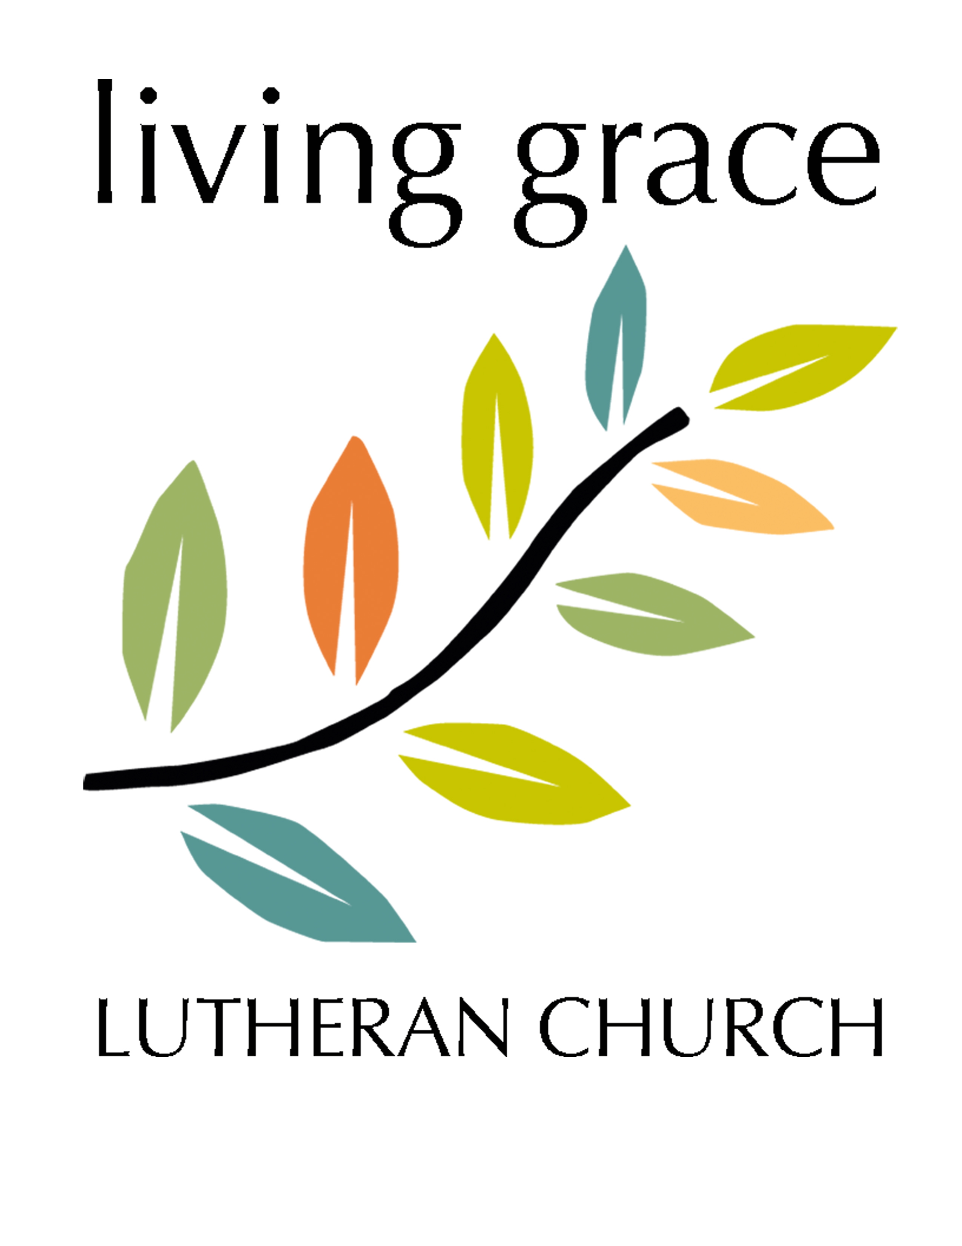
2019 Annual Meeting
Sunday, January 27, 2019 (9:30 AM)

“The community of Living Grace exists to make known God’s love
and grace by welcoming everyone, sharing the story of Jesus,
growing in faith, and serving beyond ourselves."

Core Values of Living Grace
- Jesus is Lord and Savior.
- We humbly welcome, accept and value everyone.
- We are strengthened in worship through Word and Sacrament.
- We value faith as an ongoing journey of renewal and growth.
- We recognize and respond to the needs in our community and the world.
- We bring God’s message of hope into the world.

Agenda:
Welcome/Call to Order

Table Topics:
- Living Grace’s Goals for 2019 (Deb Andvik)
- Coalition/Partnership with Gran-Park-Rollag Parish Update/New Contract
  - Mutual Ministry between Living Grace and GPR
  - Discussion of 2018 events, plans for 2019
  - Previous Goals:
- Stewardship Financial Resources
  - Financial Report (Prepared by Brett Dahl)
  - Fundraising
  - (Audit Committee: _________________, ________________)

- Lent/Holy Week Schedule
We are scheduled to host/serve the service/noon lunch on Wed. March 27 @ UMC-Hawley
Will do joint Wednesday evening Lenten Services with GPR.
- Summer Worship – in what ways can we build on success from 2018?

Leadership Team:
Craig Larson, Deb Andvik, Galen Andivk, Alicia Carley,
Loretta Ramstad (Secretary), Brett Dahl (Treasurer)

Outreach Positions:
2 Delegates to Northwestern MN ELCA Synod Assembly Gathering
(Friday/Saturday, June 7-9 @ Concordia College, Moorhead – includes Bishop’s Election)
_______________________ _____________________

Living Grace 2019 Statistical Report
2012 2013 2014 2015 2016 2017 2018
Disciples (Members) 36 49 49 54 53 54 52
Associate Disciples (Members) 2 2 2 2 2 2
Potential Disciples (Members) 54 61
Baptisms 0 1 0 0 1 0 1
Confirmation(s) 0 0 0 1 3 0 0
First Communion 3
Deaths 1 0 1 0 2 0 1
Transfer of Membership (out) 1 1 0
Transfer of Membership (in) 2 0

Attendance Statistics: 2011 2012 2013 2014 2015 2016 2017 2018
Average Sunday Worship 28 29 29 26 20 20 16 17
Average Winter/Spring (Jan-May) 26 24 32 25 22 23 24 17
Average Summer Worship 29 24 26 21 17 14 13 20
Average Fall Worship (Sept-Dec) 30 30 28 30 18 20 17 15
Average Advent Midweek Worship 15 -- -- -- -- -- -- --
Lent Worship (w/GPR) 82
Easter Worship 64 68 43 35 38 46 38 28
Christmas Worship 57 69 58 36 32 32 45 30
Sunday School 3 5 5 5 1 6 1 2
Confirmation --- --- 1 4 3 0 0 1
Post-Confirmation/Luther League 1 4 4 4

Financial Notes:
Our income includes: Pledged Money, Loose Offering, Special Gifts, Memorial General Funds, and previously ELCA/NW MN Synod Grants (ELCA has provided more than $123,000). Beginning March 2017, we began a collaboration and partnership with GPR Parish, who contracts with Living Grace for half of Pr. Hope’s time.
In addition to these resources, we need to create a signature event (monthly or annually) that can also help offset ministry funding needs.

- ELCA Grant was $15,000 in 2016; $10,000 in 2017; $0 in 2018
- The following amounts were taken out of the Mission Investment Fund in 2018:
  - Jan. $0 May $1,500 Sept. $2,000
  - Feb. $2,000 June $2,000 Oct. $1,000
  - Mar. $ 500 July $2,000 Nov. $ 750
  - April $2500 Aug. $2,000 Dec. $1,350
TOTAL: $17,600
A Snapshot of Offering for 2018
MONTH | 2018 Offering | MONTH | 2018 Offering | MONTH | 2018 Offering
January | $3,269 | May | $2,965  Noisy: $206.32 | September | $2,005
February | $2,582 | June | $2,045 | October | $2,703
March | $1,974 | July | $2,586 | November | $2,103
April | $2,948 | August | $2,729 | December | $3,339
 |  |  |  | TOTAL | $31,454.32

2017 Offering: $31,382.00
2018 Offering: $31,456.32 Proposed 2019 Budget is attached.
2019 Budget – In Words and Actions:
“The community of Living Grace exists to make known God’s love and grace by welcoming everyone, sharing the story of Jesus, growing in faith, and serving beyond ourselves."

Welcoming Everyone:
- Movie Events
- Summer Evening Fellowship Events
- Women’s Ministry Special Events
- Youth opportunities (synod gatherings, special activities)

Sharing Jesus’ Story - We bring God’s message of hope into the world:
- Regular Worship
- Active in Hawley Ministerial
- Pocket Prayer Shawls
- Woodworking Ministry

Growing in our Faith – We value faith as an ongoin gjourney of renewal and growth:
- Worship – We are strengthened in worship through Word and Sacrament
- Women’s Mutual Ministry: Bible Studies, Book Discussions, Special Events/Retreats
- Hartford Homes Bible study (Third Thursday of each month, open to community)
- Wednesday Morning Bible Study (at Rollag)
- Youth Activities/Fundraisers/Working together to rebuild Luther League with Gran-Park-Rollag.
- In 2018, Living Grace sent 4 youth and Pastor Hope to the National Youth Gathering in Houston. The congregation paid the down payment of $250/participant, totally $1,000.
- Continued joint confirmation with GPR.

Serving Beyond Ourselves:
- God’s Work. Our Hands Outreach
- The youth help prepared meals at the Ronald McDonald House
- SNAP Food Box Distribution
- Pastor Hope serves on the REACH Board and several members volunteer their time at REACH – helping with the thrift store!
- Supporting the Wider Mission of the Church: We recognize and respond to the needs in our community and the world. Our congregation's work extends beyond our own community but goes "from our doorsteps to the ends of the earth." In the past 6 years, we have given benevolence support to the Northwestern MN Synod, REACH, families in need, school milk supplies, etc. This past year, we gave over $200 to the Hawley Public School Milk Money Fund.

A Ministry Collaboration: Gran-Park-Rollag and Living Grace
GPR Parish:
Gran: 67 Active Baptized Members; 5 Inactive Baptized Members; Avg. Attendance: 20
Park: 59 Active Baptized Members; 18 Inactive Baptized Members; Avg. Attendance: 18
Rollag: 481 Active Baptized Members; 39 Inactive Baptized Members; Avg. Attendance: 117
Youth: Between Rollag-Gran-Park and Living Grace: Over 100 youth

Parish Staff:
Pr. Jim Greene (FT) and Pr. Hope Deutscher (PT-GPR/PT Living Grace)
Bea Young, PT Secretary
Youth Leader – OPEN Position
Pam Aakre – Organist for Rollag and Gran

Collaboration/Partnership
- Began in 2015 with joint confirmation and youth events (informal partnership)
- Formalized in March 2017
  - GPR contracts with Living Grace for half of pastor’s time
  - Mutual Ministry Team created with one lay person from each congregation
  - Annually renewed in annual budget

2017 Collaboration Goals
- Do 4 joint services between GPR/Living Grace in 2018.
  - We did 2 in 2017 (LG Open House and Viking Park; we can double this in 2018!!)
- Pr. Hope being present in all 4 churches; Pr. Jim being more present at Living Grace.
- Make sure all 17 people enjoy the National Youth Gathering and come home energized!

Joint Worship Services and Events
- Our first year we intentionally invited one another into each other’s worship space.
- Viking Park Outdoor Parish Worship service (annually in July)
- Living Grace held an open house (June 2017)
- Gran holds Yearly Patriotic Service and an evening auction/bake sale
- Movie Nights at The Garrick Theater
- Joint dinner at Ella Marie’s Café – food and fellowship – building a bigger table! (Fall 2018)
- This Sunday: Family Bowling Event at Bowling Alley in Hawley

Mutual Ministry Team
- Meets regularly to discuss partnership opportunities and issues as they arise. Representative from each congregation. Deb Andvik and Loretta Ramnstad have served on this team.
- Goals - 2018:
  - Develop and implement a Lay Leadership Program: It is our intention to involve as many people as possible in areas which feed a person’s soul and challenges/uses their gifts.
  - Develop and implement a Women’s Mutual Ministry Team: To support current ministries and to evolve other ministries which don’t strive to have formal structure or financial concerns.
  - Increase Committee Involvement: To move past the “we’ve always done it this way” to “what makes sense in our changing world.”

Women’s Mutual Ministry
- Kick-Off Event held at Garrick Theater in May 2018 featuring Taunya Todd; theme: Growing in Faith.
- Bi-monthly One Night Book Discussions: Present Over Perfect by Shauna Niequist; Christian Atheist by Craig Groeschel (became a weekly adult bible study unconnected to women’s ministry); When God Doesn’t Fix It by Laura Story; March: Unexpected by Christine Kaine; May: Sensible Shoes: A Story about the Spiritual Journey by Sharon Garlough Brown
- Bi-monthly/monthly Bible Discussions at local restaurants/churches
- Faith and Creativity Retreat (Fall 2018); Second one will be held March 2019.
- New Year New Beginnings – Collected 57 purses to distribute to women who don’t have a purse for a variety of reasons. 30 women came together to fill the purses with essential items, along with faith cards and pocket prayer shawls. The purses will be shared with Hawley, Detroit Lakes and Moorhead agencies.

Pocket Prayer Shawl Ministry
- GPR and Living Grace partnered with Bethlehem Lutheran in Ulen to make over 600 pocket prayer shawls for the NW MN 2018 Synod Assembly.
- We continue this ministry….sharing prayer shawls with individuals who are grieving, ill or know someone who is grieving/ill. We hand them out at grocery stores, work, local agencies, etc. To date – we estimate over 700 have been distributed across the region, the state and beyond.

Where’s the Holy Spirit Leading us next?
- Re-engage with previous goals:
  - Joint Worship services between Living Grace/GPR.
  - Pastors and lay members present at all four congregations.
  - Youth - Take energy from NYG participants to enhance engagement with older youth – keep the energy and Holy Spirit moving in their lives!
  - Lay Leadership Program – continue to encourage and build up this vital ministry – as lay people share gifts of leading worship and sharing faith stories/meditations, etc.
- New Goals:
  - Women’s Ministry – Build on Energy and invite women from community/neighboring churches to our events.
  - What are other ways we can engage within our partnership – and with the communities of Rollag, Hawley, Barnesville, etc.?
  - OTHER?

Mission Developer Report – January 2019
By Hope Deutscher
I continue to be grateful for the partnership between Living Grace and Gran-Park-Rollag! Two years into the partnership, I’m amazed by the ministry happening in ways I could not have imagined a year ago: hundreds of pocket prayer shawls being distributed to people who need to know they are loved by Jesus – and us; 4 of Living Grace’s youth and Pr. Hope attended the National Youth Gathering this summer in Houston; women are invited to attend monthly Bible studies and book discussions; women have reached out into our community providing purses for women who are in need; women have held special events, including Growing in our Faith with Tanya Todd, Faith and Creativity Retreat and New Year, New Beginnings (Purse event) – all of which saw community members invited and participating!
A member of GPR recently said to me, Living Grace is an example of how to be creative in leading worship without a pastor, in being community-minded and involved in our community, reaching out. How would you describe Living Grace? How are we continuing to be transformed by the Holy Spirit in our context? In our community and in our partnership?
There are still areas to work on. I still hear comments like, “GPR is getting the better deal. They’re getting more of Pastor Hope’s time.” We welcome these comments and questions – it allows me to examine how I am spending my time and how we all are in partnership with GPR, not just the pastors! All of the areas that I have become engaged with (mainly women and youth) are areas of ministry that Living Grace has lifted up as important ministry they wanted to have opportunities in for the past five years. I believe the partnership has brought energy and excitement to those two ministry areas.
For Living Grace, a significant portion of my time has to be spent preparing for worship on Sunday morning – from studying and writing sermon, creating a meaningful worship experience (choosing themes, hymns, writing elements of worship, etc.), preparing the bulletins, office work, etc. As well, I lead a monthly bible study at Hartford Homes, and lead worship services at Hawley Senior Living on a rotating basis and on the fifth Tuesdays I lead a Bible study at Northside Terrace.
As we continue on this partnership journey, there have been some challenges as we learn more about each congregation’s personalities, the various gifts and ministries we all are equipped to bring to the partnership! As we welcome everyone, share Jesus’ story, grow in faith and serve beyond ourselves, may we remember that God, the Father, Son and Holy Spirit is in our midst, guiding, empowering, and inspiring us to agile and courageous in our dreams.

God’s Blessings to you!
Pastor Hope Deutscher, Mission Developer for Living Grace
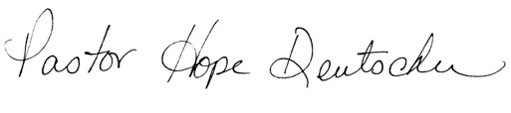

SOAR (Strengths, Opportunities, Aspirations, Results) – September 2018
A framework for Vision and Mission
STRENGTHS
What has God already placed in our midst that God can build upon through us? In other words, what is working here?

- Commitment of those involved
- Sense of community – like family (take good/bad)
- Friendships
- Compassion/kindness/not being judged
- Making people feel welcome – acceptance
- Prayer chain
- Not held back by what has been done in the past but looking at things differently!

OPPORTUNITIES
What are the “opportunities” for mission God reveals in this community?
What is God longing for us to see? What are our longings as God’s people working for God’s mission of being disciples?
- Inviting others to join services.
- More movies with GPR and invite other churches. Suggestions: Mercy Me/ I Can Only Imagine
- Women’s ministry – invite and participate
- Fundraiser….suggested Soups: Other Countries; MPR recently did a story on a group that sold grilled cheese sandwiches… we could do different kinds of grilled cheese sandwiches.

ASPIRATIONS
What is God placing on our hearts that we deeply care about /want deeply to happen? What does God care about that you deeply care about? What do we “aspire” to do as God reveals these opportunities and strengths? What do you WANT TO get passionate about here? What is the Holy Spirit placing in your heart?
- Hope to continue outreach to Ronald McDonald, REACH, Milk Money at school, etc.
- Growth in membership
- Look at last directive in scripture, vs. 11-12: in our dreams, while we are small, we do great things but we also need to focus on doing church services well – remember not to look at the actions necessary to provide a service as chores but to do them diligently as we praise God.
  - Basic element of worship: tithing. The first portion is the redemptive portion. So, in the same way, coming to church at the first of the week is a way of giving the Lord the first of your time.

Results
What’s one thing God is calling us to see, that we could do together?
What’s one (or maybe 2) goal(s) you would be willing to work on in the next six months to a year? (SMART Goals: Strategic, Measurable Attainable and Relevant Timeline)
- Important to keep a strong base here – we need a base/foundation to focus on out there. Worship – being church is an integral part of who we are. People look at us as strong – it’s interesting to see how we project strength and commitment as Living Grace. We see problems and take it for granted, but others see potential and special.
- Reach out and help others (service) at Ronald McDonald House, REACH, Milk $ for students, etc.

